Customer Shopping Behavior Analysis

1. Project Overview
This project analyzes customer shopping behavior using transactional data from 3,900 purchases across various product categories. The goal is to uncover insights into spending patterns, customer segments, product preferences, and subscription behavior to guide strategic business decisions.

2. Dataset Summary
- Rows: 3,900
- Columns: 18
- Key Features:
- Customer demographics (Age, Gender, Location, Subscription Status)
- Purchase details (Item Purchased, Category, Purchase Amount, Season, Size, Color)
- Shopping behavior (Discount Applied, Promo Code Used, Previous Purchases, Frequency Of Purchases, Review_Rating, Shipping_Type)
- Missing Data: 37 values in Review Rating column

3. Exploratory Data Analysis using Python

We began with data preparation and cleaning in Python:

● Data Loading: Imported the dataset using pandas.
● Initial Exploration: Used df.info() to check structure and .describe() for summary statistics.

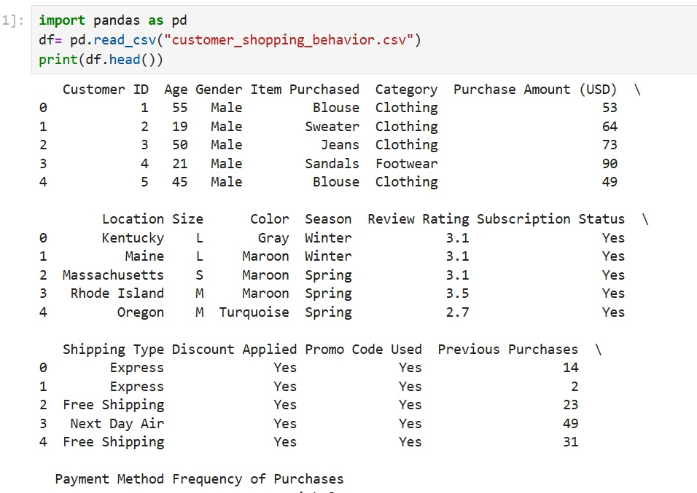
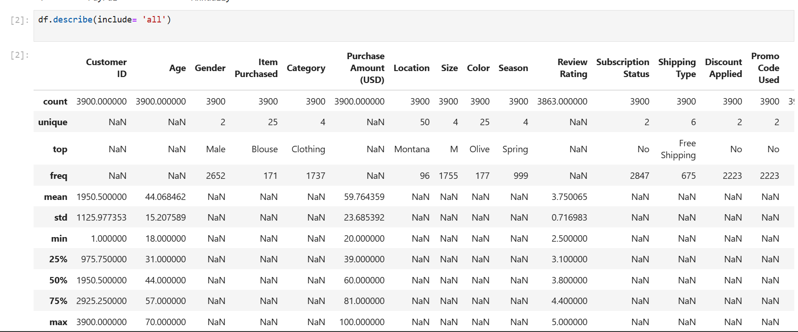
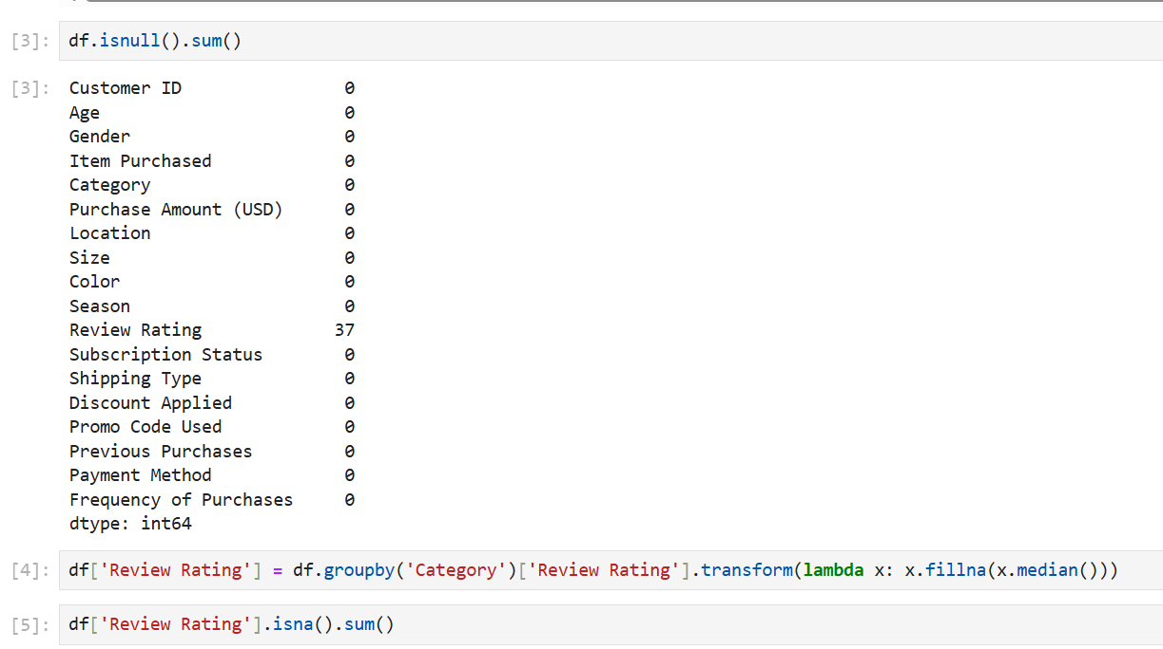
● Missing Data Handling: Checked for null values and imputed missing values in the Review Rating column using the median rating of each product category.
● Column Standardization: Renamed columns to snake case for better readability and documentation. 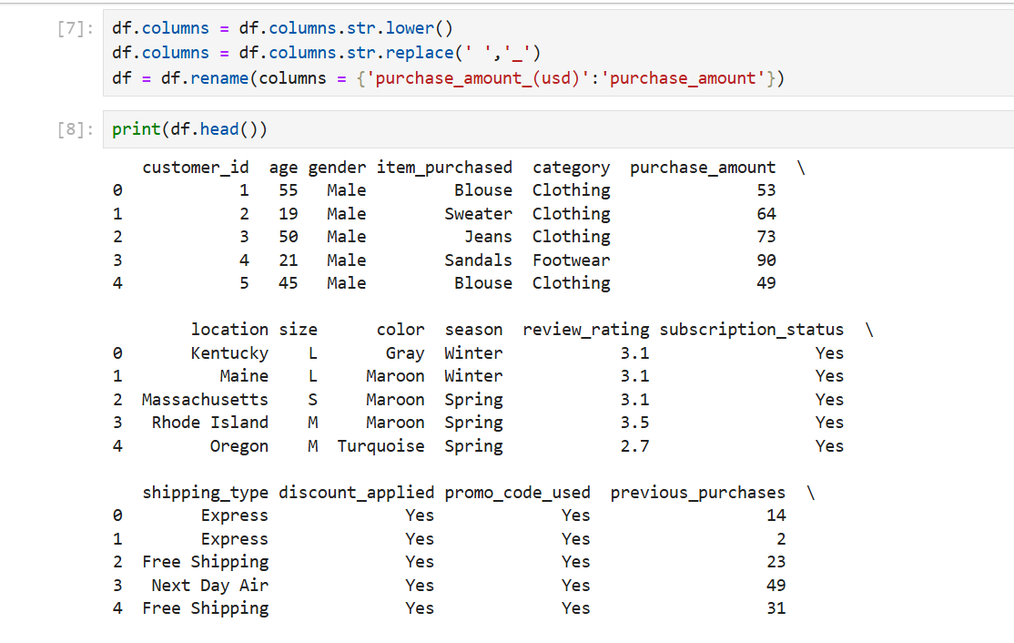

● Feature Engineering:
○ Created age_group column by binning customer ages.
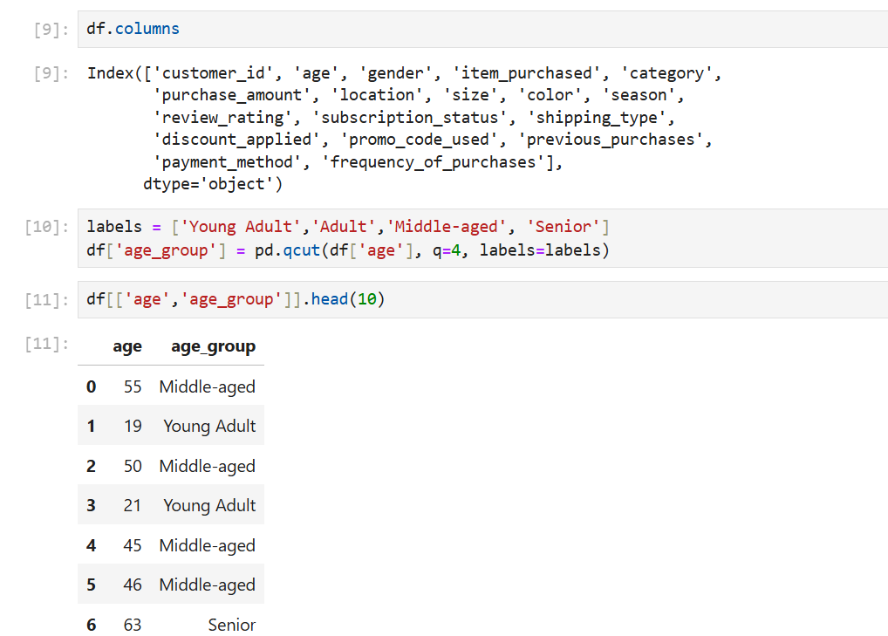

○ Created purchase_frequency_days column from purchase data.

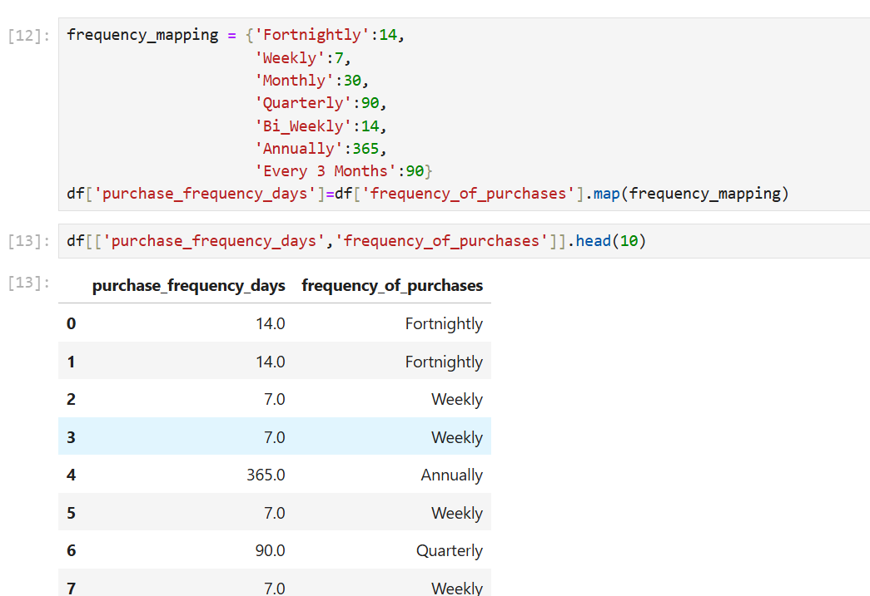
● Data Consistency Check: Verified if discount_applied and promo_code_used were redundant; dropped promo_code_used.

● Database Integration: Connected Python script to PostgreSQL and loaded the cleaned DataFrame into the database for SQL analysis.

4. Data Analysis using SQL (Business Transactions)

We performed structured analysis in SQL Server to answer key business questions:

--Q1. What is the total revenue generated by male vs. female customers?
select gender, sum(purchase_amount) as revenue
from customer_data
group by gender;
--Q2. Which customers used a discount but still spent more than the average purchase amount?
select customer_id, purchase_amount
from customer_data
where discount_applied = 'yes' and purchase_amount>=(select avg(purchase_amount) from customer_data);
-- Q3. Which are the top 5 products with the highest average review rating?
select top 5
item_purchased, round(avg(cast(review_rating as float)),2) as Average_Product_Rating
from customer_data
group by item_purchased
order by avg(review_rating) desc;
--Q4. Compare the average Purchase Amounts between Standard and Express Shipping.
select shipping_type, round(avg(purchase_amount),2) as avg_purchase_amount
from customer_data
where shipping_type in ('Standard','Express')
group by shipping_type;
--Q5. Do subscribed customers spend more? Compare average spend and total revenue
--between subscribers and non-subscribers.
SELECT subscription_status,
COUNT(customer_id) AS total_customers,
ROUND(AVG(purchase_amount),2) AS avg_spend,
ROUND(SUM(purchase_amount),2) AS total_revenue
FROM customer_data
GROUP BY subscription_status
ORDER BY total_revenue,avg_spend DESC;
--Q6. Which 5 products have the highest percentage of purchases with discounts applied?
SELECT top 5
item_purchased,
ROUND(100.0 * SUM(CASE WHEN discount_applied = 'Yes' THEN 1 ELSE 0 END)/COUNT(*),2) AS discount_rate
FROM customer_data
GROUP BY item_purchased
ORDER BY discount_rate DESC;
--Q7. Segment customers into New, Returning, and Loyal based on their total
-- number of previous purchases, and show the count of each segment.
with customer_type as (
SELECT customer_id, previous_purchases,
CASE
WHEN previous_purchases = 1 THEN 'New'
WHEN previous_purchases BETWEEN 2 AND 10 THEN 'Returning'
ELSE 'Loyal'
END AS customer_segment
FROM customer_data)
select customer_segment, count(*) as number_of_customers
from customer_type
group by customer_segment;
--Q8. What are the top 3 most purchased products within each category?
with item_count as ( select category,item_purchased, count(customer_id) as total_order,
row_number() over (partition by category order by count(customer_id) desc) as item_rank from
customer_data
group by category, item_purchased)
select category , item_rank, item_purchased, total_order
from item_count
where item_rank<=3;
--Q9. Are customers who are repeat buyers (more than 5 previous purchases) also likely to subscribe?
SELECT subscription_status,
COUNT(customer_id) AS repeat_buyers
FROM customer_data
WHERE previous_purchases > 5
GROUP BY subscription_status;
--Q10. What is the revenue contribution of each age group?
SELECT
age_group,
SUM(purchase_amount) AS total_revenue
FROM customer_data
GROUP BY age_group
ORDER BY total_revenue desc;

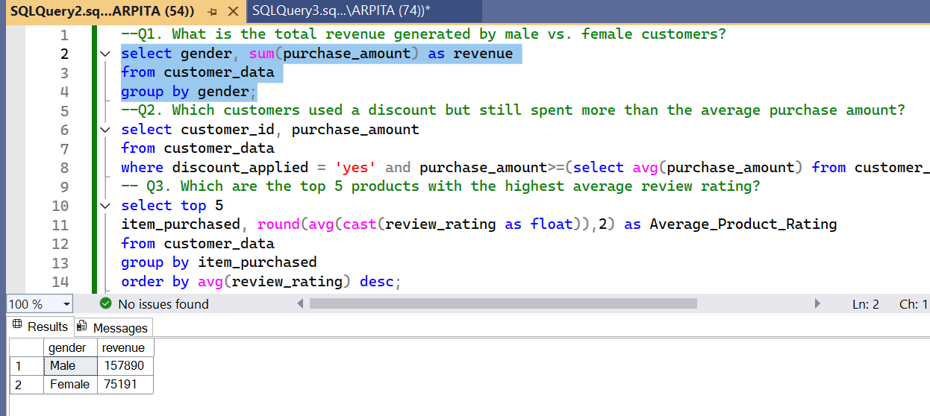
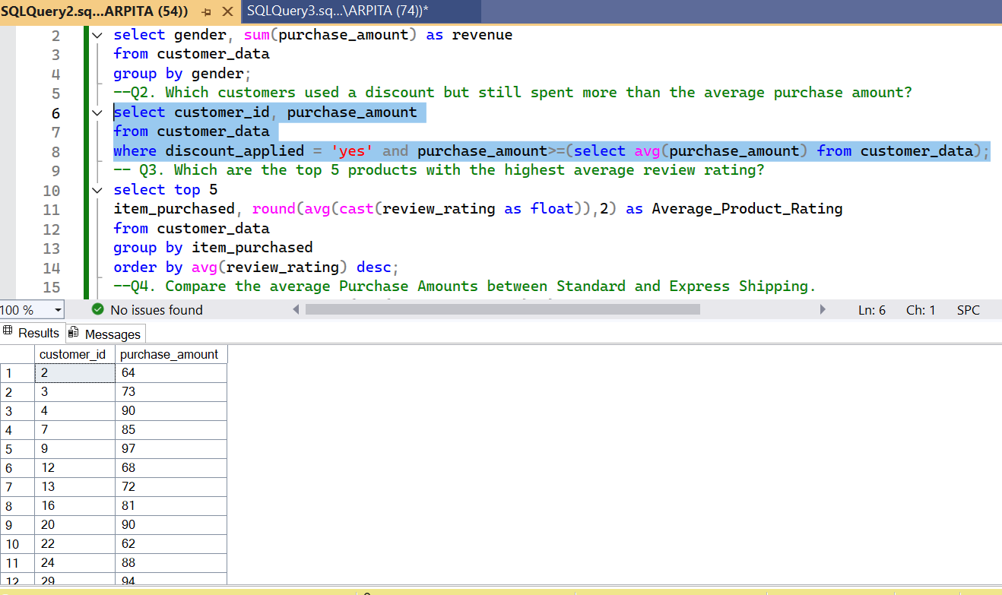
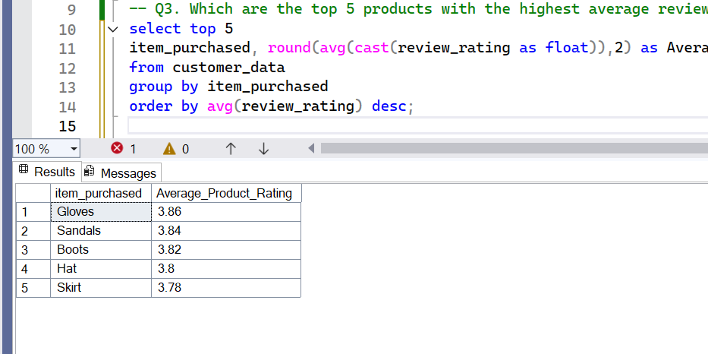

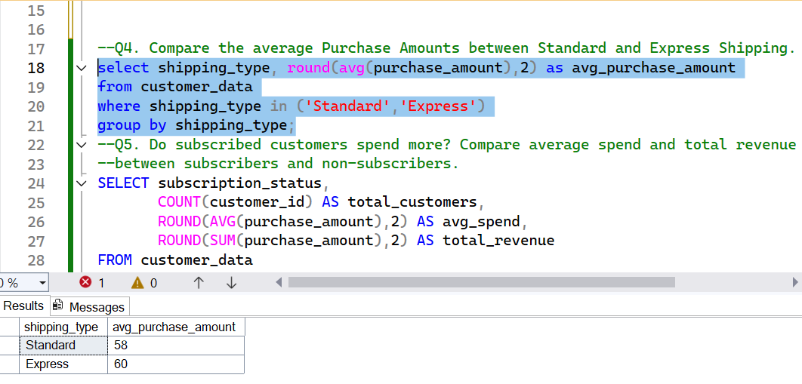

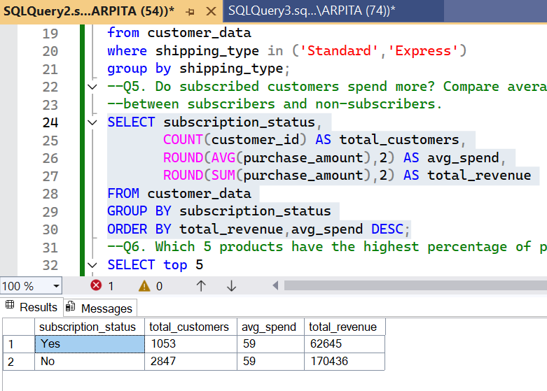
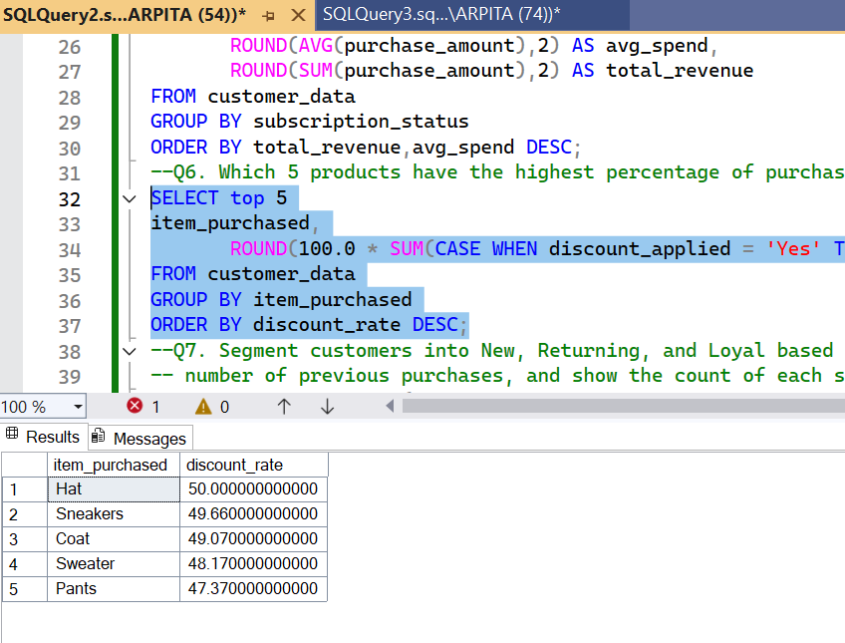
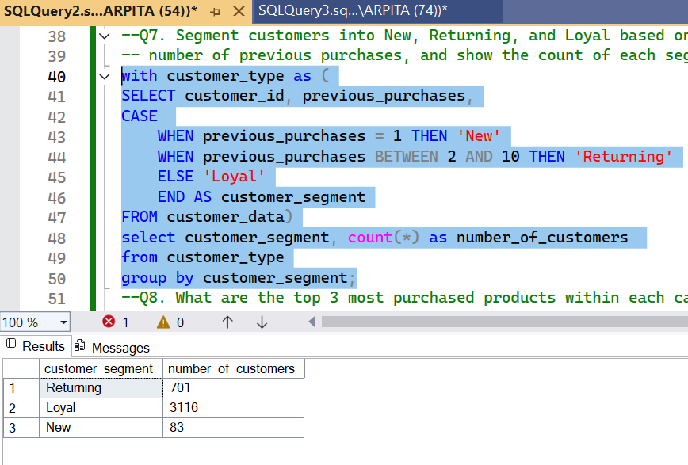

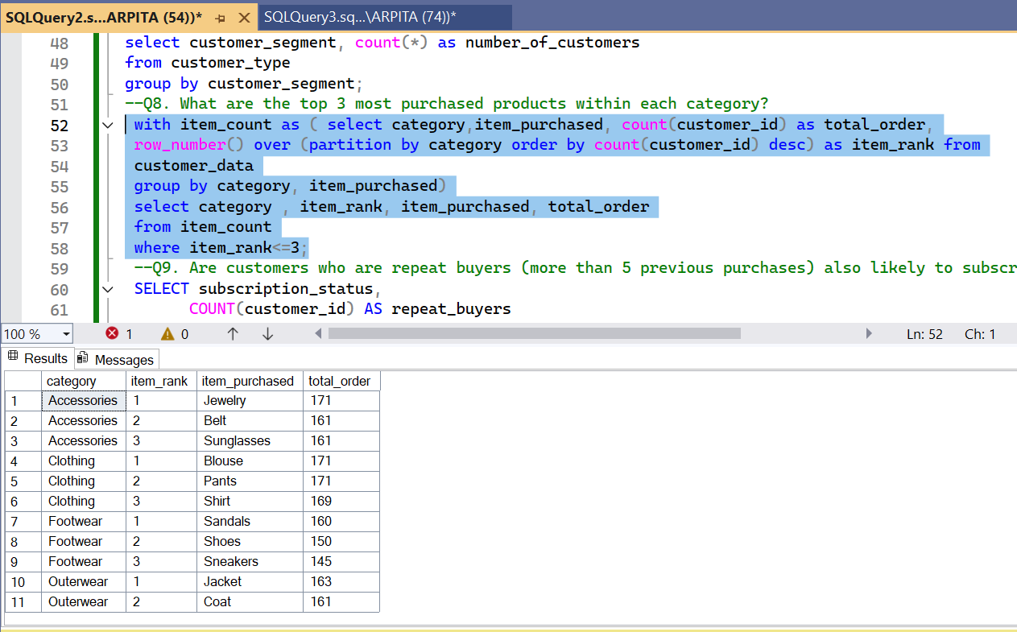
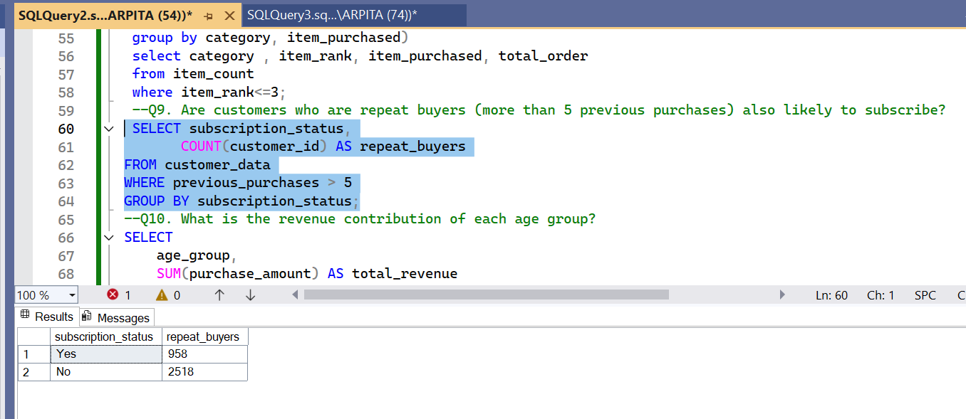

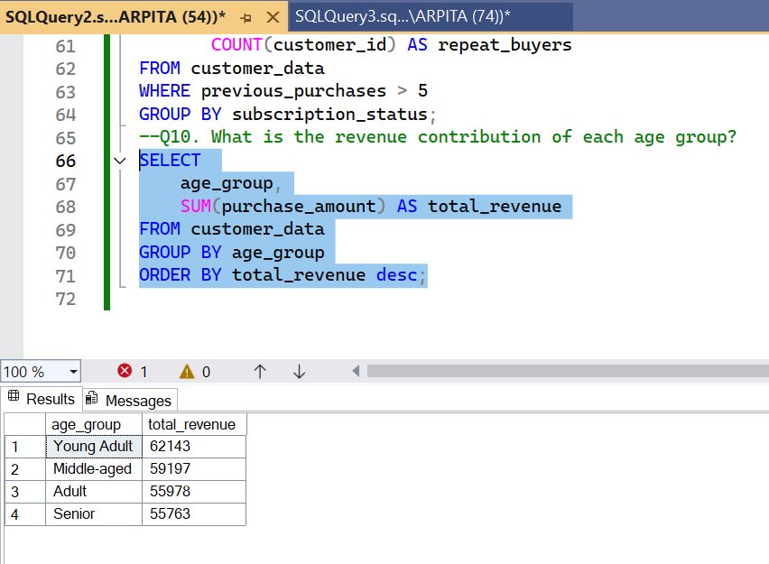

5. Dashboard in Power BI

Finally, we built an interactive dashboard in Power BI to present insights visually.

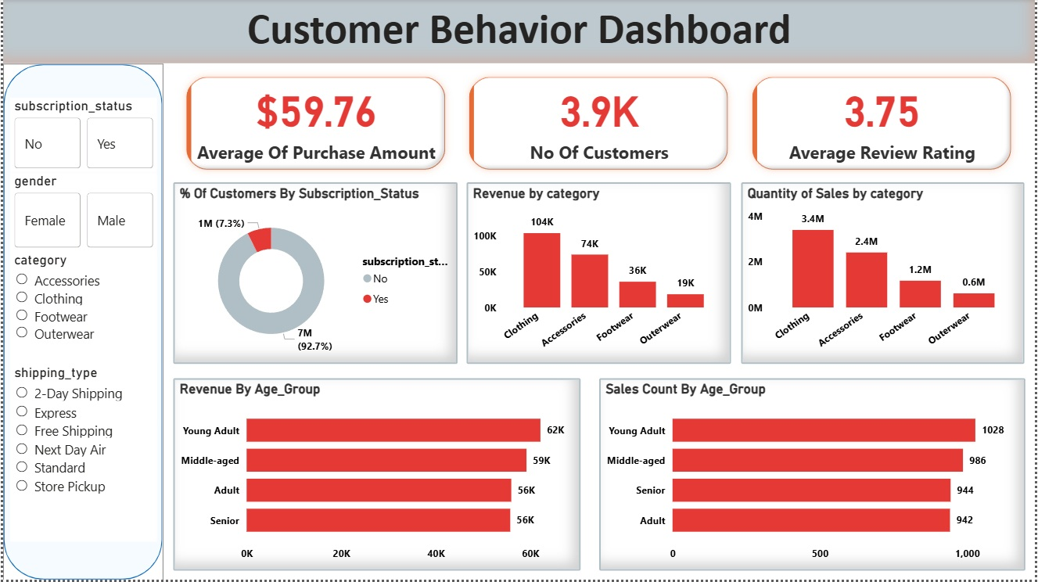

6. Business Recommendations

● Boost Subscriptions – Promote exclusive benefits for subscribers.
● Customer Loyalty Programs – Reward repeat buyers to move them into the “Loyal” segment.
● Review Discount Policy – Balance sales boosts with margin control.
● Product Positioning – Highlight top-rated and best-selling products in campaigns.
● Targeted Marketing – Focus efforts on high-revenue age groups and express-shipping users.

